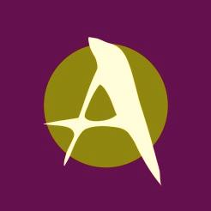
THE ARTS
CENTER of
the CAPITAL REGION
2017 Community Arts Final Report From

Please complete a final report form for each funded project.
Due 30 days after the completion of the project, no later than March 15, 2018.

Organization:

Contact Person:

Project Title:

Part I: Budget Information
Please complete a Final Report Budget Sheet (available online: www.artscenteronline.org/community-arts-grants/ or by request).

Part II: Project Information
Please type answers into a Word document using no more than two (2) pages.
- What were the strengths of your funded program? How do you feel it made an impact to the community?
- How did the Community Arts Grant funding make a difference?
- Do you plan to apply for Community Arts Grant funding for 2018/19?
- Do you have any suggestions for improvements or changes in the Community Arts Grant program?
- Attach copies of press releases, posters, flyers, images, etc. from your funded project.

Name Title

Signature Date

Please retain a copy of this report for your files. Return this original form immediately following completion of the program, no later than March 15, 2018 to:

Chris Ristau
The Arts Center of the Capital Region
265 River Street
Troy, NY 12180

