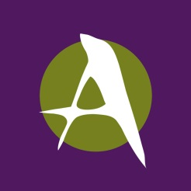
THE ARTS
CENTER of
the CAPITAL REGION

2017 Arts in Education Final Report From

Please complete a final report form for each funded project.
Due 30 days after the completion of the project, no later than March 15, 2018.

Teaching Artist:

School:

Project Title:

Project Information
Please type answers into a Word document, using no more than two pages.
1. What were the strengths of your funded program? How do you feel it made an impact on the students?
2. How did the Arts Education funding make a difference?
3. Do you plan to apply for Arts Education funding for 2018?
4. Do you have any suggestion for improvements or changes in the Arts Education program?
5. Attach copies of pictures, press releases, posters, flyers, etc. from your funded project.

Name Title

Signature Date

Please retain a copy of this report for your files. Return this original form immediately following completion of the program, no later than March 15, 2018 to:

Chris Ristau
The Arts Center of the Capital Region
265 River Street
Troy, NY 12180

