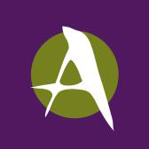
This project is made possible in part through a Community Arts Grant, a program funded by The Arts Center of the Capital Region through the New York State Council on the Arts.

